Name: ____________________________ Surname: ____________________________ N^{ber}: ____ Grade/Class: _____
Assessment: _____________________________ | Date: ___________________________________________________
 | Teacher’s signature:  ___________________________ | Parent’s signature:  ___________________________

Write a sentences about visiting the zoo. Use five of the following animals in your story.
Monkeys / Giraffes / Elephants / Hippos / Lions / Penguins / Bears / Zebras / Koalas / Crocodiles / Kangaroos / Dolphins / Wolves
The visit to the zoo

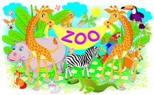

Example: When I go to the zoo I like to see the giraffes. The giraffes have long necks and they have spots on their body. They are very tall. ________________________________________________________________________________________________________________________________________________________________________________________________________________________________________________________________________________________________________________________________________________________________________________________________________________________________________________________________________________________________________________________________________________________________________________________________________________________________________________________________________________________________________________________________________________________________________________________

