Name: ____________________________ Surname: ____________________________ N^{ber}: ____ Grade/Class: _____
Assessment: _____________________________  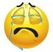  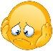  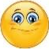 | Date: ___________________________________________________
 | Teacher’s signature:  ___________________________ | Parent’s signature:  ___________________________

- Listen and write.
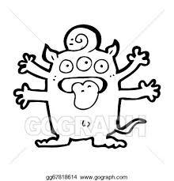

I’m Dodo. This is my ______. It’s _____.

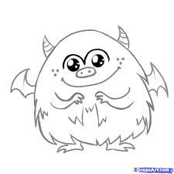

I’m Kiki. This is my ______. It’s _____.

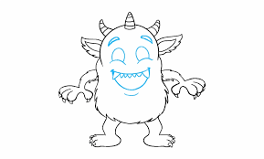

I’m Buba. This is my ______. It’s _____.

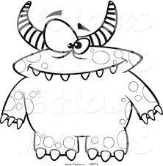

I’m Riri. This is my ______. It’s _____.

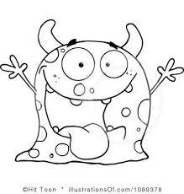

I’m Momo. This is my ______. It’s _____

Script:
- I’m Dodo. This is my hand. It’s pink.
- I’m Kiki. This is my nose. It’s purple
- I’m Buba. This is my face. It’s yellow.
- I’m Riri. This is my body. It’s orange.
- I’m Momo. This is my mouth. It’s green.

Script:
- Pink monster : Open your eyes
- Green monster : Raise your hand
- Yellow monster : Wave your arms
- Brown monkey : Clap your hands
- Red monster : Jump

