Name: ____________________________ Surname: ____________________________ N^{ber}: ____ Grade/Class: _____
Assessment: _____________________________  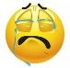  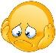  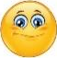 | Date: ___________________________________________________
 | Teacher’s signature:  ___________________________ | Parent’s signature:  ___________________________

- Listen and choose.
b.

- Touch your ________________.

a. b.

- Wave your ________________.

a. b.

- Clap your ________________.

a. b.
- Stamp your ________________.

a. b.
- Point to your ________________.

Script:

- Touch your nose.
- Wave your arm.
- Clap your hands.
- Stamp your feet.
- Point to your head.

