Name: ____________________________ Surname: ____________________________ N^{ber}: ____ Grade/Class: _____
Assessment: _____________________________ | Date: ___________________________________________________
 | Teacher’s signature:  ___________________________ | Parent’s signature:  ___________________________

- Listen and tick.

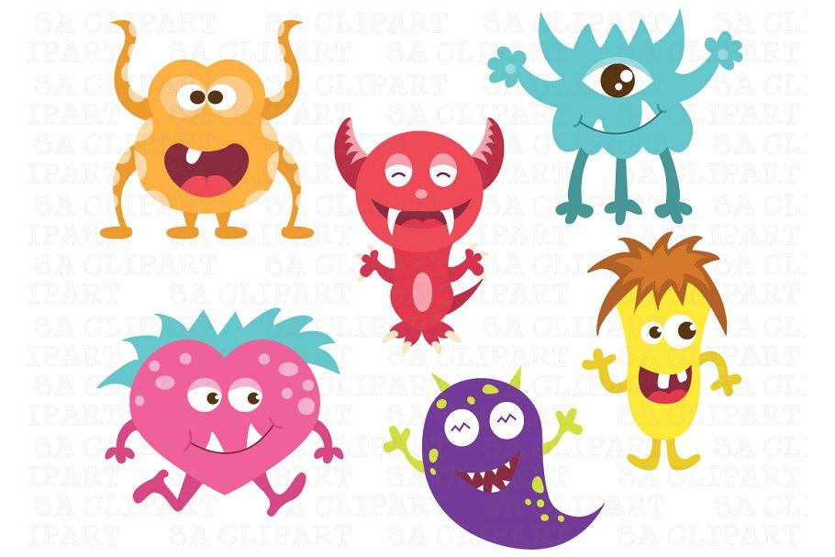

1
2

Script:

- Hi! My name’s Molly. I have got one eye, two teeth, two arms and three legs.
- Hi! My name’s Trip. I have got two eyes, seven teeth, two arms.I haven’t got legs.

