Name: ____________________________ Surname: ____________________________ N^{ber}: ____ Grade/Class: _____
Assessment: _____________________________  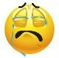  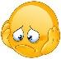  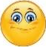  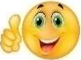  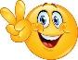 | Date: ___________________________________________________
 | Teacher’s signature:  ___________________________ | Parent’s signature:  ___________________________

- Listen and tick the right word. Draw the body part

1 2 3

_____ HAIR _____ KNEE _____ HAND
_____ MOUTH _____ TOE _____ EYE

4 5 6

_____ ARM _____ HAND _____ EAR
_____ LEG _____ FINGER _____ EYE

7 8 9

_____ HEAD _____ HEAD _____ FEET
_____ HAND _____ HAIR _____ ARMS

Script:

- It’s my mouth.
- It’s my toe.
- It’s my hand.
- It’s my arm.
- It’s my finger.
- It’s my ear.
- It’s my head.
- It’s my hair.
- It’s my feet.

