Name: ____________________________ Surname: ____________________________ N^{ber}: ____ Grade/Class: _____
Assessment: _____________________________  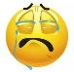  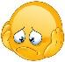  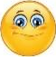 | Date: ___________________________________________________
 | Teacher’s signature:  ___________________________ | Parent’s signature:  ___________________________

- Read and draw.
I have got blonde hair.
I have got blue eyes.
I have got a small nose.
I have got a big mouth and white teeth.
I have got small ears.

