Name: ____________________________ Surname: ____________________________ N^{ber}: ____ Grade/Class: _____
Assessment: _____________________________ | Date: ___________________________________________________
 | Teacher’s signature:  ___________________________ | Parent’s signature:  ___________________________

- Write True or False
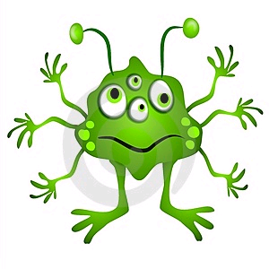
True or False
He has got one mouth. ____________
He has got three eyes. ____________
He has got six hands. ____________
He has got six toes. ____________
He has got five arms. _____________
He has got two legs. ______________

Answer key:
- T
- F
- T
- T
- F
- T

