Name: ____________________________ Surname: ____________________________ N^{ber}: ____ Grade/Class: _____
Assessment: _____________________________  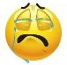  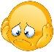  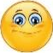  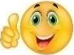 | Date: ___________________________________________________
 | Teacher’s signature:  ___________________________ | Parent’s signature:  ___________________________

- Look at the pictures and tell them.
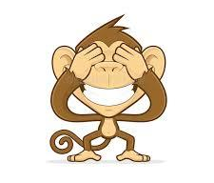
Close ...................................................
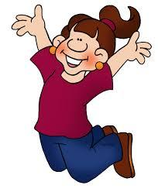
J.....................
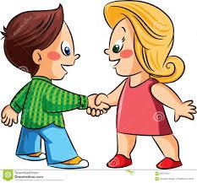
Shake ......................................................
Point .........................................................

Answer key

- Close your eyes
- Jump
- Shake your hands
- Point to your head

