Name: ____________________________ Surname: ____________________________ N^{ber}: ____ Grade/Class: _____
Assessment: _____________________________  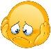  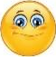 | Date: ___________________________________________________
 | Teacher’s signature:  ___________________________ | Parent’s signature:  ___________________________

- Look and mime the picture to your partner. S/he will guess.

Student A
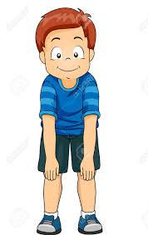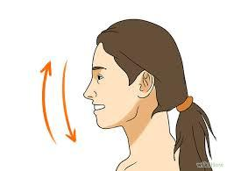

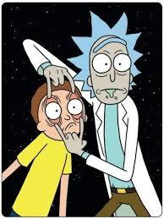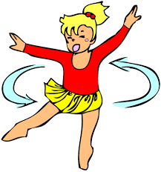

- Look and mime the picture to your partner. S/he will guess.

Student B

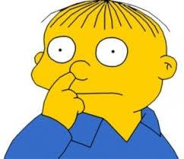

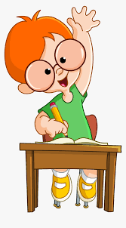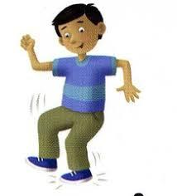

Answer key:
Student A
Show your knees
Nod your head
Open your eyes
Turn around

Student B:
Touch your nose
Clap your hands
Raise your hand
Stamp your feet

