Name: ____________________________ Surname: ____________________________ N^{ber}: ____ Grade/Class: _____
Assessment: _____________________________  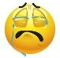  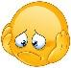  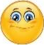 | Date: ___________________________________________________
 | Teacher’s signature:  ___________________________ | Parent’s signature:  ___________________________

- Look and say the monsters’ body moves. Ex: “Touch your nose.”
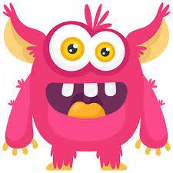

1.___________________________________

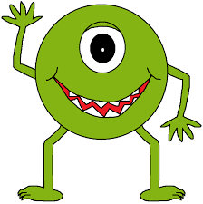

2.___________________________________

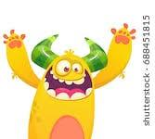

3.___________________________________

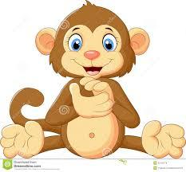

4.___________________________________

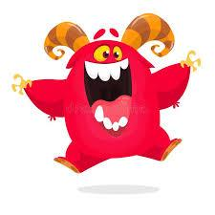

5.___________________________________

Script:
- Pink monster : Open your eyes
- Green monster : Raise your hand
- Yellow monster : Wave your arms
- Brown monkey : Clap your hands
- Red monster : Jump

