Name: ____________________________ Surname: ____________________________ N^{ber}: ____ Grade/Class: _____
Assessment: _____________________________  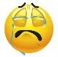  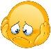  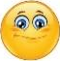 | Date: ___________________________________________________
 | Teacher’s signature:  ___________________________ | Parent’s signature:  ___________________________

- Look at the picture and tell.

Ex: What is it? It’s a …..

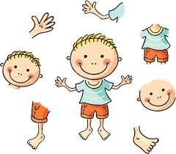

Answer key

What is it?
- It’s a hand.
- It’s a head.
- It’s a body.
- It’s an arm.
- It’s a face.
- It’s a leg.
- It’s a foot.

