Name: ____________________________ Surname: ____________________________ N^{ber}: ____ Grade/Class: _____
Assessment: _____________________________  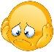 | Date: ___________________________________________________
 | Teacher’s signature:  ___________________________ | Parent’s signature:  ___________________________

- Do the crossword puzzle.
Across Down
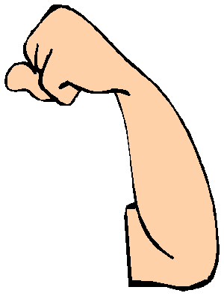
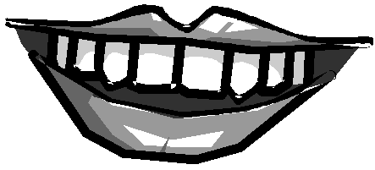
1 a _ _ 2 m_ _t _
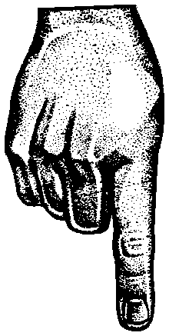
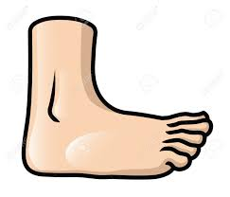
3 f _ _t 4 f_ _ g _r
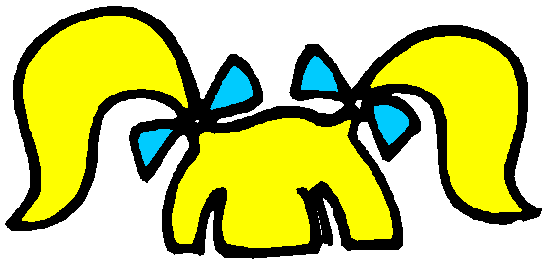
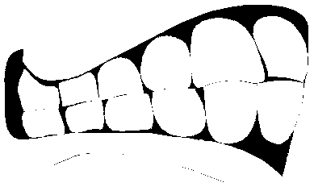
5 h_ i _ 6 t_ _ th
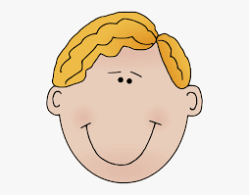
7 e _ _ s 8 h_ _d
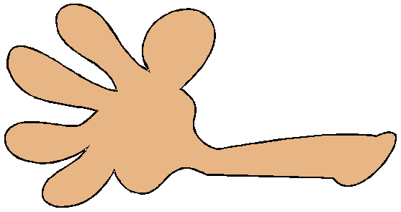
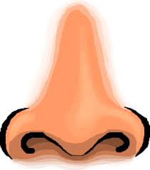
9 h _ _ d 10 n_ s _
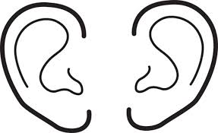
11 e_ r _

1
3
4
11
9
7
6
2
10
8
5

Answer key

Across Down
1 a rm 2 mout h
3 feet 4 finger
5 hair 6 teeth
7 e yes 8 head
9 hand 10 nose
11 ears

