Name: ____________________________ Surname: ____________________________ N^{ber}: ____ Grade/Class: _____
Assessment: _____________________________  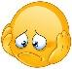 | Date: ___________________________________________________
 | Teacher’s signature:  ___________________________ | Parent’s signature:  ___________________________

- Look and put the letters in order.

ADEH- _________
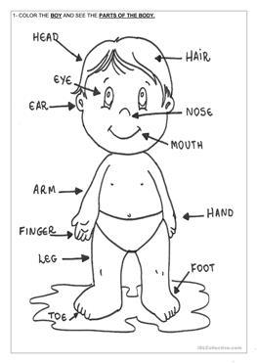

İHAR- _________

ENSO- _________

EKEN- _________

RIGNFE- _________

UHTOM- _________

MRA- _________

RAE- _________

YEE- _________

AHND- _________

FOTO- _________

Answer Key

Head, eye, ear, hair, nose, mouth, arm, finger, knee, hand, foot

