Name: ____________________________ Surname: ____________________________ N^{ber}: ____ Grade/Class: _____
Assessment: _____________________________  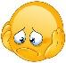 | Date: ___________________________________________________
 | Teacher’s signature:  ___________________________ | Parent’s signature:  ___________________________

- Look and write the body parts.

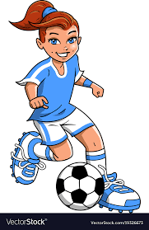

Answer key:
Head, ear, eye, mouth, arm, hand, finger, knee, feet

