Name: ____________________________ Surname: ____________________________ N^{ber}: ____ Grade/Class: _____
Assessment: _____________________________  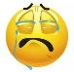  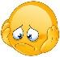  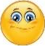 | Date: ___________________________________________________
 | Teacher’s signature:  ___________________________ | Parent’s signature:  ___________________________

- Describe the monsters.

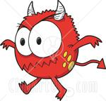 | The monster has got ..............arms, .............. hands and .......... fingers. It's got ............ legs, ............ feet and .............toes. It's got ................ horns, two big .............. and a .......................
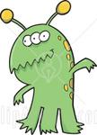 | The .............................. got three ..................and three ................ It's got two ...........and two .................It's got six ........................ and eleven ..................... It's got ............horns (antennas).
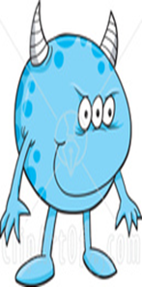 | ...............................................................................................  ................................................................................................  ................................................................................................  ................................................................................................

Answer Key

The monster has got two arms, two hands and six fingers. It's got two legs, two feet and six toes. It's got two horns, two big eyes and a tail /head.
The monster has got three legs and three feet It's got two arms and two hands. It's got six fingers and eleven toes. It's got two horns (antennas).
The monster has got two horns, two hands,two legs and two feet. It has got eight fingers. It has got three eyes and a very big mouth.

