Name: ____________________________ Surname: ____________________________ N^{ber}: ____ Grade/Class: _____
Assessment: _____________________________  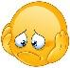 | Date: ___________________________________________________
 | Teacher’s signature:  ___________________________ | Parent’s signature:  ___________________________
- Look and write.
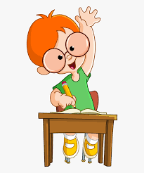 ________raise your hand________.
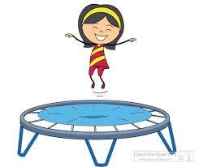 ________________________________________________.

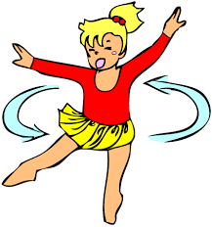 ________________________________________________.

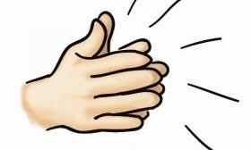 ________________________________________________.
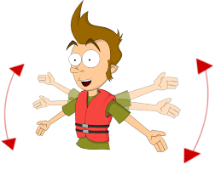 ________________________________________________.

Answer Key
- Raise your hand
- Jump
- Turn around
- Clap your hands
- Wave your arms

