Name: ____________________________ Surname: ____________________________ N^{ber}: ____ Grade/Class: _____
Assessment: _____________________________  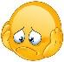 | Date: ___________________________________________________
 | Teacher’s signature:  ___________________________ | Parent’s signature:  ___________________________

- Read, order and write.

- is / what / this ? _______________________________.
- finger / is / this / my. _______________________________.
- your / hand / it / is. _______________________________.
- this / your / is / finger. _______________________________.

- Write and match the pictures

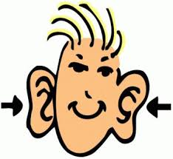
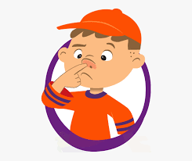
have / I / ears / two / got / .
is / my / this / head / .
blue / has / got / she / eyes / ?
it / four / has / hands / got / .
is / foot / my / it / .
touch / nose / your / .

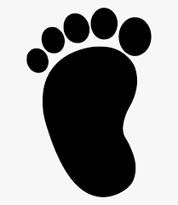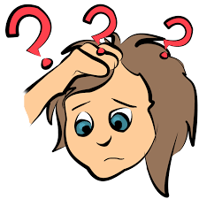

Answer key:
- What is this?
- This is my finger
- It is your hand
- This is your finger

- I have got two ears
- This is my head
- Has she got blue eyes?
- It has got four hand
- It is my foot
- Touch your nose

