Name: ____________________________ Surname: ____________________________ N^{ber}: ____ Grade/Class: _____
Assessment: _____________________________ | Date: ___________________________________________________
 | Teacher’s signature:  ___________________________ | Parent’s signature:  ___________________________

- Listen and fill in the blanks.
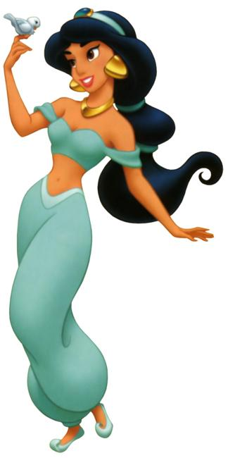
Her name is Princess Jasmine.
She is ………………. and ……………..
She has got ……………... and ………………….hair.
She has ………………….and ……………………eyes.

Script:
She is tall and thin.
She has got long and black hair.
She has got big and brown eyes.

