Name: ____________________________ Surname: ____________________________ N^{ber}: ____ Grade/Class: _____
Assessment: _____________________________  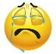  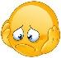  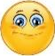 | Date: ___________________________________________________
 | Teacher’s signature:  ___________________________ | Parent’s signature:  ___________________________

- Listen and complete the monster.

Script:
Hello! I’m Ken. I have got 6 red arms. I have got one mouth and three teeth. I haven't got a nose but I have got two big ears. My ears are green. My teeth are white. And I haven’t got hair. I have got a black moustache, but I haven’t got a beard.

