Name: ____________________________ Surname: ____________________________ N^{ber}: ____ Grade/Class: _____
Assessment: _____________________________  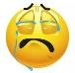  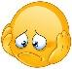  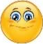 | Date: ___________________________________________________
 | Teacher’s signature:  ___________________________ | Parent’s signature:  ___________________________
Read and complete.
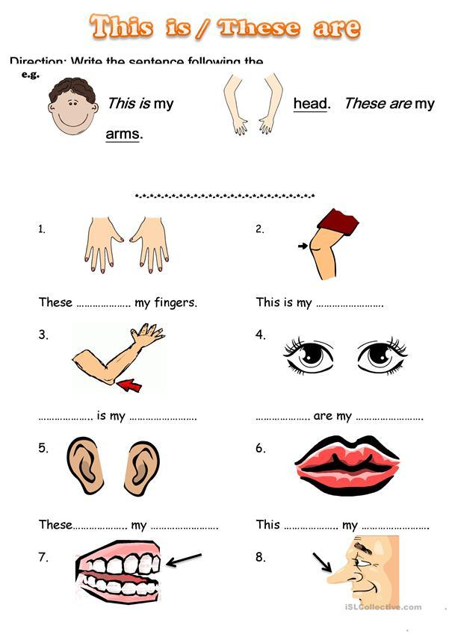

Answer Key

are
These
knee
arm
this
ears
are
eyes
mouth
is
nose
is
teeth
are

