Name: ____________________________ Surname: ____________________________ N^{ber}: ____ Grade/Class: _____
Assessment: _____________________________ | Date: ___________________________________________________
 | Teacher’s signature:  ___________________________ | Parent’s signature:  ___________________________

- Read and fill in the blanks.
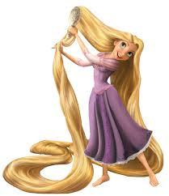
Rapunzel has got long ..................

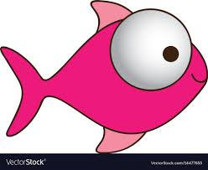
Fishy has got big ..................

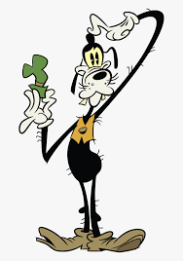
Goofy has got thin ..................

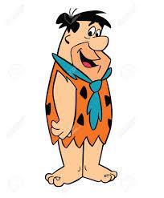
Fred has got a big ..................

Eric has got small ..................

Answer key:
- Hair
- Eyes
- Arms
- Mouth
- Ears

