Name: ____________________________ Surname: ____________________________ N^{ber}: ____ Grade/Class: _____
Assessment: _____________________________ | Date: ___________________________________________________
 | Teacher’s signature:  ___________________________ | Parent’s signature:  ___________________________
- Read and match.
Daniel has got three eyes.He has got circle face.He has got two arms and two feet.He is blue and pink.

Joe is black and red.He has got three legs and feet.He has got three yellow eyes.

Geo is short.He has got one eye.He is yellow and Brown.He has got two arms and two legs.

Sam hasn’t got a nose.He has got four eyes.Two eyes are blue.Two eyes are green.He has got orange body.

Ben has got two eyes.One eye is big and the other is small.He has got two teeth.He is white and purple.

Somi has got four hands.He hasn’t got a nose.He has got three eyes.He is blue ,red and orange.

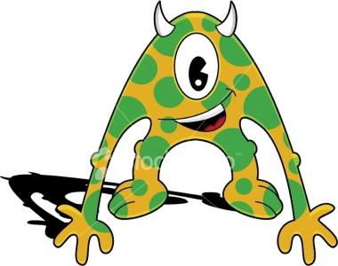
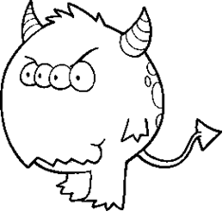
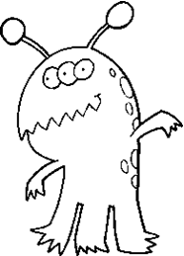

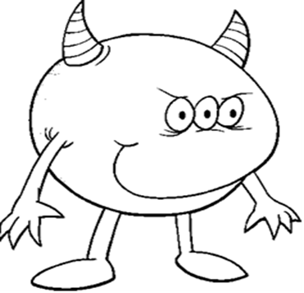

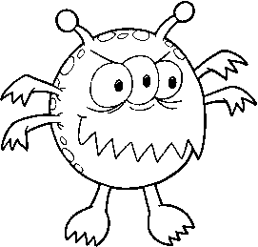

Answer Key
- Read and match.
Daniel has got three eyes.He has got circle face.He has got two arms and two feet.He is blue and pink.

Joe is black and red.He has got three legs and feet.He has got three yellow eyes.

Geo is short.He has got one eye.He is yellow and Brown.He has got two arms and two legs.

Sam hasn’t got a nose.He has got four eyes.Two eyes are blue.Two eyes are green.He has got orange body.

Ben has got two eyes.One eye is big and the other is small.He has got two teeth.He is white and purple.

Somi has got four hands.He hasn’t got a nose.He has got three eyes.He is blue ,red and orange.

