Name: ____________________________ Surname: ____________________________ N^{ber}: ____ Grade/Class: _____
Assessment: _____________________________ | Date: ___________________________________________________
 | Teacher’s signature:  ___________________________ | Parent’s signature:  ___________________________

- Look at the pictures, answer the questions according to the circled one and tell the opposite.

Are you tall?
- Yes, I am. / No, I’m not.
TALL - SHORT

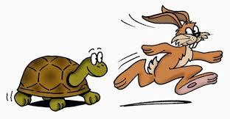
Are you big?
- .........................

Are you fast?
- .........................

Are you weak?
- .........................
Are you old?
- .........................

FAST - .............
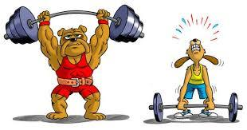
WEAK - ............

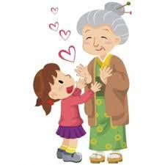
OLD - .............

BIG - .............
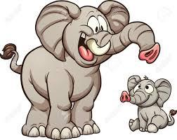

Answer Key

No, I’m not fast - slow
Yes, I am weak - strong
Yes, I am old - young
No, I’m not big - small

