Name: ____________________________ Surname: ____________________________ N^{ber}: ____ Grade/Class: _____
Assessment: _____________________________  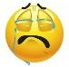  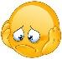  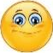  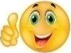  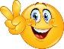 | Date: ___________________________________________________
 | Teacher’s signature:  ___________________________ | Parent’s signature:  ___________________________

Student A

- Ask your partner “ Has it got .......?” and try to draw your friends monster.

- Answer your partner’s questions by looking at your monster.

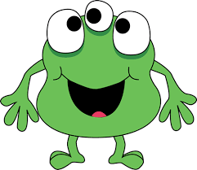

Student B

- Answer your partner’s questions by looking at your monster.

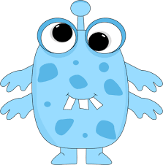

- Ask your partner “ Has it got .......?” and try to draw your friends monster.

