Name: ____________________________ Surname: ____________________________ N^{ber}: ____ Grade/Class: _____
Assessment: _____________________________ | Date: ___________________________________________________
 | Teacher’s signature:  ___________________________ | Parent’s signature:  ___________________________

- Look and tell. Which sense is this?
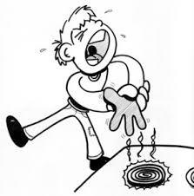

- Look and tell.

Answer key
smell-taste-hear-touch-see

- We see with our eyes.
- We smell with our nose.
- We hear with our ears.
- We touch with our hands.
- We taste with our tongue.

