Name: ____________________________ Surname: ____________________________ N^{ber}: ____ Grade/Class: _____
Assessment: _____________________________  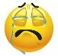  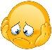  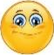  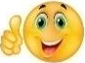 | Date: ___________________________________________________
 | Teacher’s signature:  ___________________________ | Parent’s signature:  ___________________________

Student A
- Look and describe your monster to your partner.

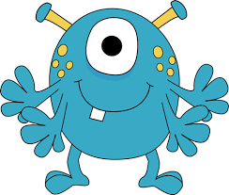

- Listen to your partner, and draw your partner’s monster.

Student B
- Listen to your partner, and draw your partner’s monster.

- Look and describe your monster to your partner.

