|  |  |  |
| --- | --- | --- |
| **Name:** ____________________________ **Surname:** ____________________________ **Nber: ____ Grade/Class:** _____ | | |
| **Assessment:** _____________________________ | **Date:** ___________________________________________________ | |
| **Teacher’s signature:**  **___________________________** | **Parent’s signature:**  **___________________________** |

**Student A**

1. **Look at the pictures and answer your partner’s question.**

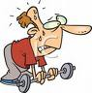

**What does she look like? What does ....................?**

**She is ............................. .......................................**

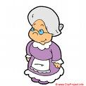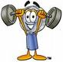

**.......................................? .......................................?**

**......................................... .......................................**

**Student B**

1. **Look at the pictures and answer your partner’s question.**

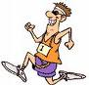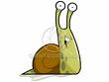

**What does he look like? What does ....................?**

**He is ............................. .......................................**

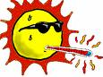

**.......................................? .......................................?**

**......................................... .......................................**

|  |
| --- |
|  |
| **Answer key:**  **Student A**  She is young  He is strong  She is old  He is weak  **Student B**  He is fast  It is slow  It is cold  It is hot |
|  |
|  |