Name: ____________________________ Surname: ____________________________ N^{ber}: ____ Grade/Class: _____
Assessment: _____________________________  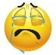  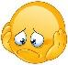  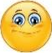  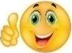 | Date: ___________________________________________________
 | Teacher’s signature:  ___________________________ | Parent’s signature:  ___________________________

- Answer the questions.
Has he got a big mouth? Has she got pink hair?
_________________________ _________________________
Has he got seven teeth? Has she got three feet?
_________________________ _________________________
Has he got three arms? Has she got four eyes?
_________________________ ________________________
_______________________________________________________________________________________________________________________________________________________________________________________________________________________________________________________________.

- Describe this monster.
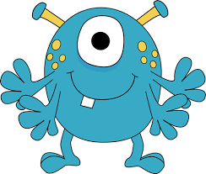

Answer key:
- Yes he has.
- No, he hasn’t.
- No, he hasn’t.
- Yes, she has.
- Yes, she has.
- No, she hasn’t.

