Name: ____________________________ Surname: ____________________________ N^{ber}: ____ Grade/Class: _____
Assessment: _____________________________  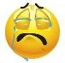  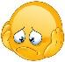  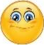  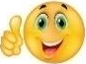  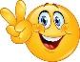 | Date: ___________________________________________________
 | Teacher’s signature:  ___________________________ | Parent’s signature:  ___________________________

- Fill in the blanks.
We hear with our _____________.
We _________ with our fingers / hands.
We _________with our eyes.
We kick a ball with our _____________.
We _________ with our nose.
We _________with our mouth.
We brush our _____________.

- Draw a monster and describe it.

Answer key:

- Ears
- touch / feel
- see
- Feet / foot
- smell
- eat / speak
- teeth

