Name: ____________________________ Surname: ____________________________ N^{ber}: ____ Grade/Class: _____
Assessment: _____________________________  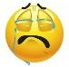  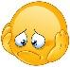  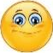  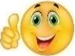 | Date: ___________________________________________________
 | Teacher’s signature:  ___________________________ | Parent’s signature:  ___________________________

- Answer the questions.
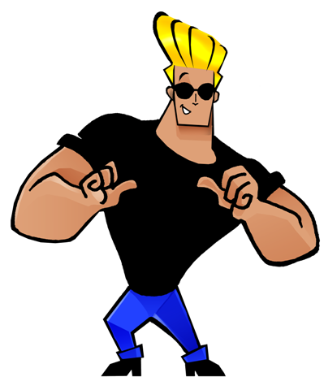

Is he fat or thin?
___________________________.

Has he got blonde or brown hair?
___________________________.

Is he old or young?
___________________________.

Is he strong or weak?
___________________________.

Is she beautiful or handsome?
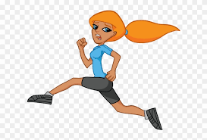
___________________________.

Has she got blue or green eyes?
___________________________.

Is she fast or slow?
___________________________.

Has she got long or short hair?
___________________________.

Answer key

The man
- He is thin.
- He has got blonde hair.
- He is young.
- He is strong.
The woman
- She is beautiful.
- She has got blue eyes.
- She is beautiful.
- She has got long hair.

