TOPIC: | SUBTOPICS: | LEVEL:
Name: ____________________________ Surname: ____________________________ N^{ber}: ____ Grade/Class: _____

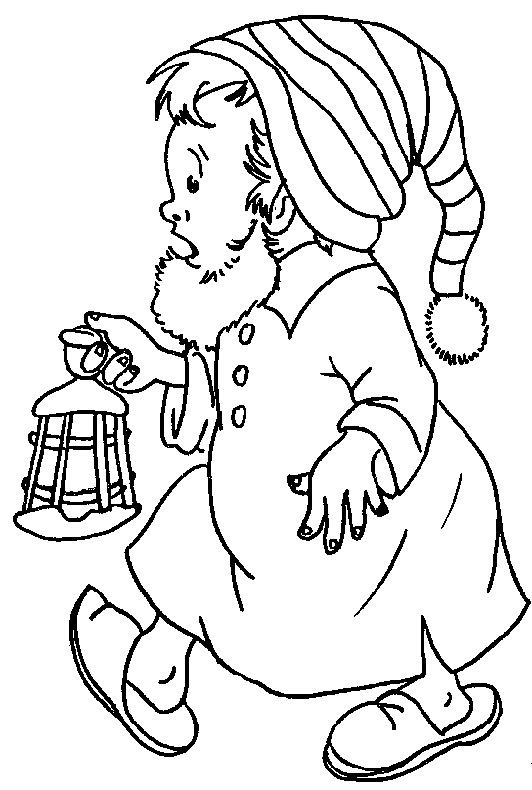
_ o e _
k _ _ e
_ e e _
a _ _ s
_ a _ d s
l _ _ s
f _ _ g _ r _
_ e _ d
_ y _ s
n _ _ _
b e _ _ d
h _ _ r
_ a _
_ o _ _ h
n _ _ k
h _ p _
b a _ _
a n _ _ _

