TOPIC: | SUBTOPICS: | LEVEL:
Name: ____________________________ Surname: ____________________________ N^{ber}: ____ Grade/Class: _____
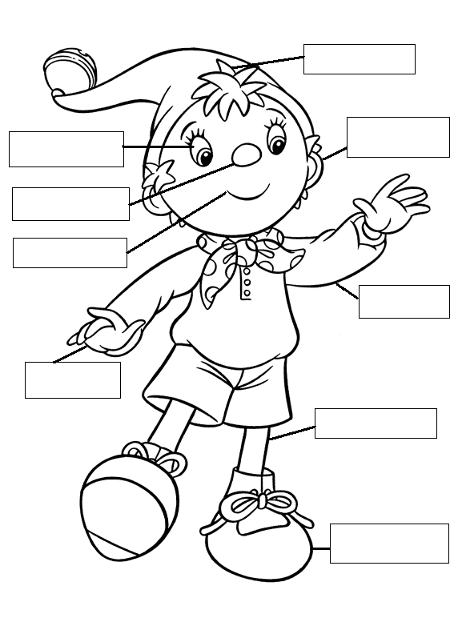

HAND LEG FOOT ARM MOUTH
EYE EAR HAIR NOSE

2- COLOUR NODDY:
Eye: Blue hat: purple sweater: yellow
Nose: Pink short:blue shoes: black
Mouth: Red

