TOPIC: | SUBTOPICS: | LEVEL:
Name: ____________________________ Surname: ____________________________ N^{ber}: ____ Grade/Class: _____
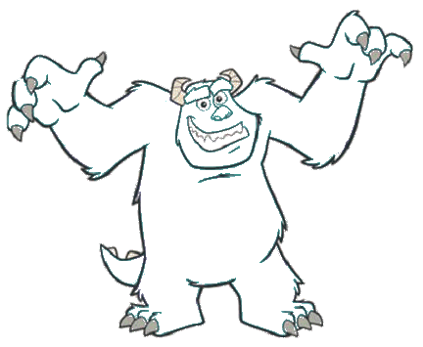

Hello, my name is Sully. I’m a monster! I have got one blue head, two green eyes, one nose and one big red mouth. I have got two big hands with four fingers and two legs with three toes. My body is blue and purple.

