TOPIC: | SUBTOPICS: | LEVEL:
Name: ____________________________ Surname: ____________________________ N^{ber}: ____ Grade/Class: _____

Write the names under the pictures.
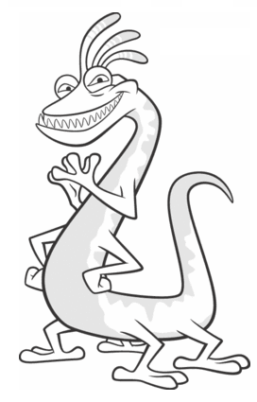
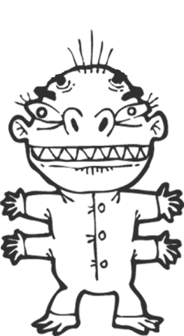
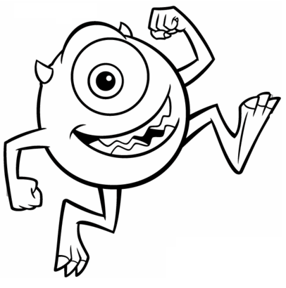
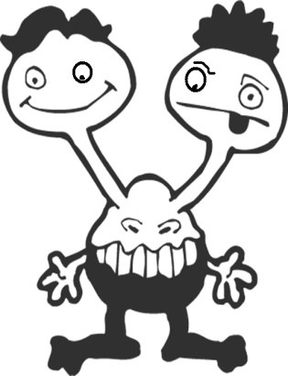

............................. .............................. ............................ ..........................

- Hello! I’m Funky. I have got four arms and hands. I have got twenty fingers! I have two big eyes and one big mouth. I have got two legs and only six toes.

- Hello! I’m Skunky. I have got one head, two eyes and big mouth. I have got four arms and four legs.

- Hi! I’m Molly. I’ve got two heads and four eyes! I have got three mouths. I have got two arms, two hand and eight fingers. I have got two legs, two feet and six toes.

- Hello! I’m Bally. I have got one head, one eye and two little horns. I have got two arms and two legs.

- Hello! I’m Tiffany. I have got one head, one eye and long hair. I have got two arms and four legs.

