TOPIC: | SUBTOPICS: | LEVEL: A2
Name: ____________________________ Surname: ____________________________ N^{ber}: ____ Grade/Class: _____

PARTS OF THE BODY
Arm - eye - eyebrow - belly - leg - breast - thumb - elbow - fist - finger - foot (plural: feet)
ankle - buttocks - hair - neck - hand - wrist - hip - chin - knee - head - lip - mouth - nose
upper arm - thigh - ear - bottom - back - underarm - lower leg - shoulder - waist - cheek
calf (plural: calves) - eyelash - tooth (plural: teeth) - toe - tongue - nostril – forehead

- 1-____________  - 2-____________  - 3-____________  - 4-____________  - 5-____________  - 6-____________  - 7-____________ | 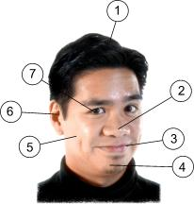 | 1-___________  2-___________  3-___________  4-___________  5-___________  6-___________  7-___________ | 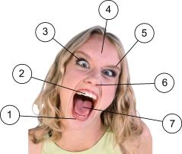

Exercise on Body Parts – Whole Body
Can you name the parts of the human body?
1-___________  2-___________  3-___________  4-___________  5-___________  6-___________  - 7-___________  - 8-___________  - 9-___________  - 10-___________  - 11-___________  - 12-___________  - 13-___________  - 14-___________  - 15-___________  - 16-___________  - 17-___________  - 18-___________  - 19-___________  - 20-___________  - 21-___________ | 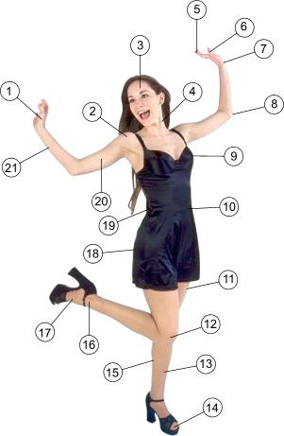

Write their names.
(wrist / foot / ear / arm / fingers / shoulder / tongue / nose / hand / eye)

1-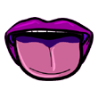 2- 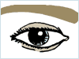 3-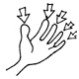 4-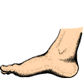 5-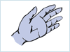
_______________ _______________ _______________ _______________ _______________

6- 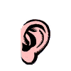 7- 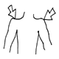 8- 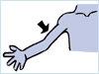 9- 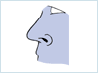 10- 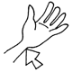
_______________ _______________ _______________ _______________ _______________

(ankle / foot / ear / arm / toes / neck / mouth / nose / hand / eye)

1- 2- 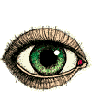 3- 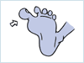 4- 5-
_______________ _______________ _______________ _______________ _______________

6- 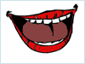 7- 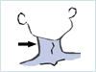 8- 9- 10- 
    

