TOPIC: | SUBTOPICS: | LEVEL:
Name: ____________________________ Surname: ____________________________ N^{ber}: ____ Grade/Class: _____

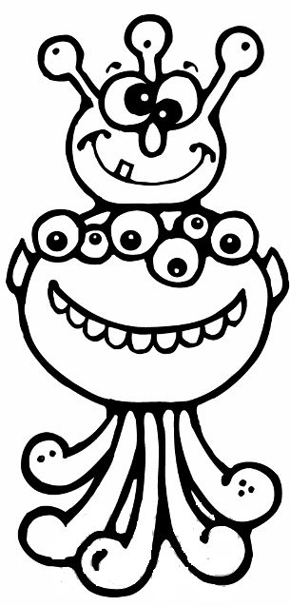

It has got two funny ears.It has got no arms.

..........................................................................................................................................................................................................................................................

.....................................................................................................................................................................................................................................................................

.....................................................................................................................................................................................................................................................................

.....................................................................................................................................................................................................................................................................

.....................................................................................................................................................................................................................................................................

.....................................................................................................................................................................................................................................................................

.....................................................................................................................................................................................................................................................................

.....................................................................................................................................................................................................................................................................

