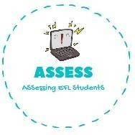
ENGLISH WORKSHEET

Writing

Name: Surname: N^{ber}: Grade/Class:
Assessment: | Date:
 | Teacher’s signature: | Parent’s signature:

1. Create a card for your mum. Include sentences of love, your name and color the bears.

Assessing EFL Students

