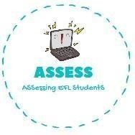
- Draw the things that are given.
Name: Surname: N^{ber}: Grade/Class:
Assessment: | Date:
 | Teacher’s signature:  _ | Parent’s signature:

ENGLISH EXAM
Reading

Cake
Balloons
Candles

- Read and fill the gaps using the words from the box.
birthday / birthday / nine / you / cake / happy / Tom / presents / January

- Happy to you, birthday to you. Happy birthday dear .

Happy birthday to .

- How old are you? I’m years old.

- When is your ?

- My birthday is in .

- My friends give me .

- On my birthday I eat chocolate .
Assessing EFL Students

