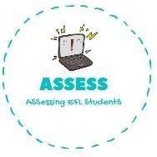
ENGLISH EXAM
Reading

Name: Surname: N^{ber}: Grade/Class:
Assessment: | Date:
 | Teacher’s signature:  _ | Parent’s signature:

- Draw the things that are given.

Reindeer
Christmas tree
Stockings

- Read and fill the gaps using the words from the box.
Father Christmas / star / balls / presents

- The is on top of the Christmas tree.

- I have many . New toys!

- is the best. He has a white beard and a red hat.

- Wow! There are so many decorations! I love the .

Assessing EFL Students

