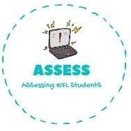
ENGLISH EXAM
Reading

Name: Surname: N^{ber}: Grade/Class:
Assessment: | Date:
 | Teacher’s signature:  _ | Parent’s signature:

- 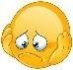Draw the things that are given.

Easter bunny
Basket
Easter eggs

- Read and fill the gaps using the words from the box.
basket / Easter eggs / Easter hunt / jelly beans

- I found three ! I have got one yellow, one green and one pink.

- I have a big . All my Easter eggs are here.

- The are so tasty!

- Come on! The is beginning!

Assessing EFL Students

