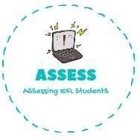
ENGLISH EXAM
Reading

Name: Surname: N^{ber}: Grade/Class:
Assessment: | Date:
 | Teacher’s signature:  _ | Parent’s signature:

- Draw the things that are given.

Witch
Ghost
Vampire

- Read and fill the gaps using the words from the box.
sweets / Halloween / cat / bats / cake / jack o’lanterns

- Happy !

- Do you have your ? Candy is my favourite.

- Do you like ? They are so cute!

- There is a black on the window.

- I love scary !

Assessing EFL Students

