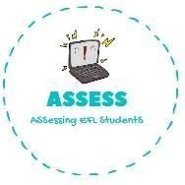
ENGLISH EXAM
Reading

Name: Surname: N^{ber}: Grade/Class:
Assessment: | Date:
 | Teacher’s signature:  _ | Parent’s signature:

- Draw the things that are given.

Turkey
Pumpkin
Peas

- Read and fill the gaps using the words from the box.
Thanksgiving / cranberry sauce / candles / turkey

- This is so tasty!

- I love . My family is so happy!

- Do you like ? It tastes so good.

- We need more light. Are there ?

Assessing EFL Students

