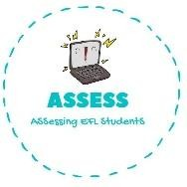
ENGLISH EXAM

Speaking

Name: Surname: N^{ber}: Grade/Class:
Assessment: | Date:
 | Teacher’s signature:  _ | Parent’s signature:

1. Look at the pictures and name them
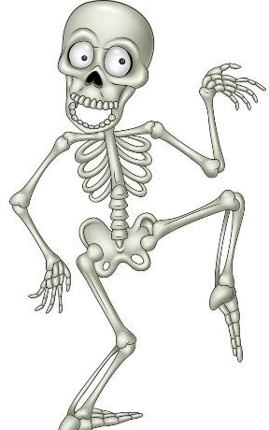

Assessing EFL Students

