TOPIC: CELEBRATIONS | SUBTOPICS: Thanksgiving (Culture bridge) | LEVEL: _A1___
Name: ____________________________ Surname: ____________________________ N^{ber}: ____ Grade/Class: _____

- Put the letter in the corresponding word.
Turkey
Cranberry sauce
Peas
Candle
Pumpkin

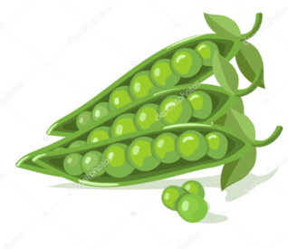
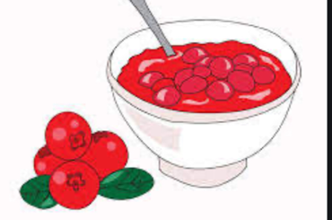
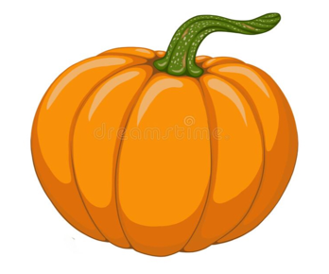
A B C

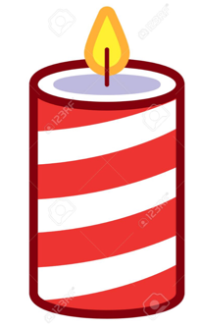
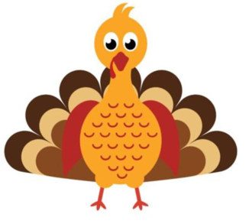
D E

