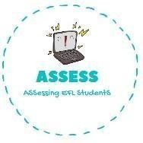
ENGLISH EXAM
Vocabulary

Name: Surname: N^{ber}: Grade/Class:
Assessment: | Date:
 | Teacher’s signature:  _ | Parent’s signature:

Order the words.

  - a-b-l-o-l-o-n-s →

  - a-c-k-e →

  - a-c-n-d-e-l-s →

  - a-p-p-r-e a-h-s-t →

  - r-p-s-e-e-t-n-s →

Put the number of the celebration from the previous exercise.
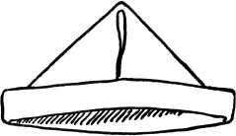

Assessing EFL Students

