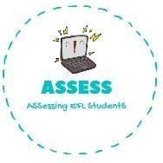
ENGLISH EXAM
Vocabulary

Name: Surname: N^{ber}: Grade/Class:
Assessment: | Date:
 | Teacher’s signature:  _ | Parent’s signature:

1. Complete the crossword.

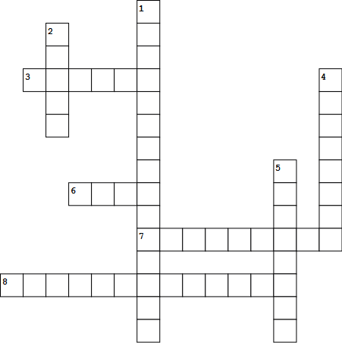

- F er Ch_i_t
- _all_
- _lei
4. P_e nt_
- _ein r
- _ta_
7. S_o in
8. Ch_ist t e

Assessing EFL Students

