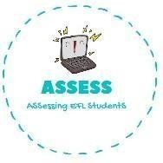
ENGLISH EXAM
Vocabulary

Name: Surname: N^{ber}: Grade/Class:
Assessment: | Date:
 | Teacher’s signature:  _ | Parent’s signature:

Order the words.

  - a-t-r-s-e u-b-n-y-n→

  - a-t-r-s-e u-h-t-n →

  - e-j-l-y-l e-a-b-s-n →

  - a-t-r-s-e g-g-e-s →

  - a-k-t-b-s-e →

Put the number of the celebration from the previous exercise.
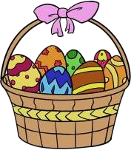

Assessing EFL Students

