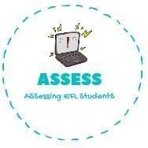
ENGLISH EXAM
Vocabulary

Name: Surname: N^{ber}: Grade/Class:
Assessment: | Date:
 | Teacher’s signature:  _ | Parent’s signature:

1. Complete the crossword.

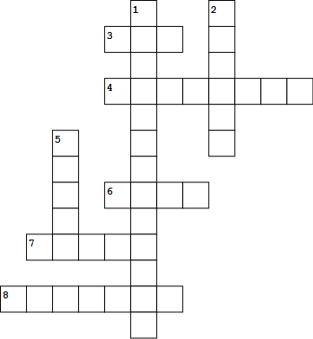

- J_ck O’_a rn
- _we s
- t
4. _k_l_t_n
- W h
- B s
- _h_st
- mp_r_

Assessing EFL Students

