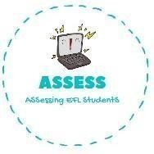
ENGLISH EXAM
Vocabulary

Name: Surname: N^{ber}: Grade/Class:
Assessment: | Date:
 | Teacher’s signature:  _ | Parent’s signature:

Order the words.

  - a-n-c-d-e-l →

  - c-a-b-r-y-r-n-e-r u-s-a-e-c →

  - u-m-p-k-n-i →

  - e-a-s-p →

  - t-k-r-u-e-y →

Put the number of the celebration from the previous exercise.
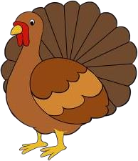

Assessing EFL Students

