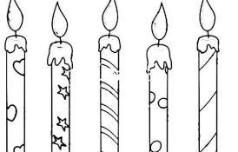
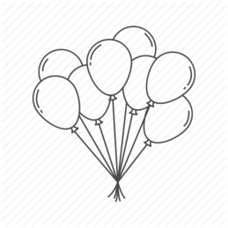
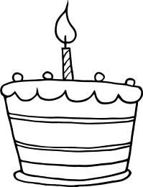

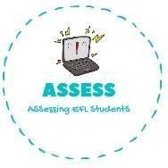
ENGLISH EXAM

Writing

Name: Surname: N^{ber}: Grade/Class:
Assessment: | Date:
 | Teacher’s signature:  _ | Parent’s signature:

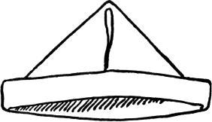
1. Order the words and paint these Birthday drawings!

a-p-p-r-e a-t-h
a-c-n-l-d-e-s
l-o-o-l-b-a-s-n
k-c-e-a
r-e-p-t-e-s-n

Assessing EFL Students

